**Spatial Analysis of Vector Data**

*Name: Mahum Manzar*

* Around 123 hurricanes of category H5 have hit the Gulf Coast since 1851.
* August 28th, 2005 was the day Hurricane Katrina became a Category 4 Hurricane for the first time.
* Orleans, Jefferson, Pearl River, St. Bernard, Hancock had an average of more than 10 inches of rainfall over the nine-day period associated with Hurricane Katrina in 2005.
* This kind of join is one-to-many. Since, one table was linked to many tables in the second data.
* The top 5 most vulnerable counties based on the socioeconomic analysis are Harris (Texas), Miami-Dade (Florida), Dallas (Texas), Bexar (Texas), and Tarrant (Texas).
* The difference between using join and relate is that. When you use the join function you direction combine tables from the data using common field. Whereas, related function you combine tables from common field but they are kept separate.
* Spatial join uses spatial relations to combine tables.

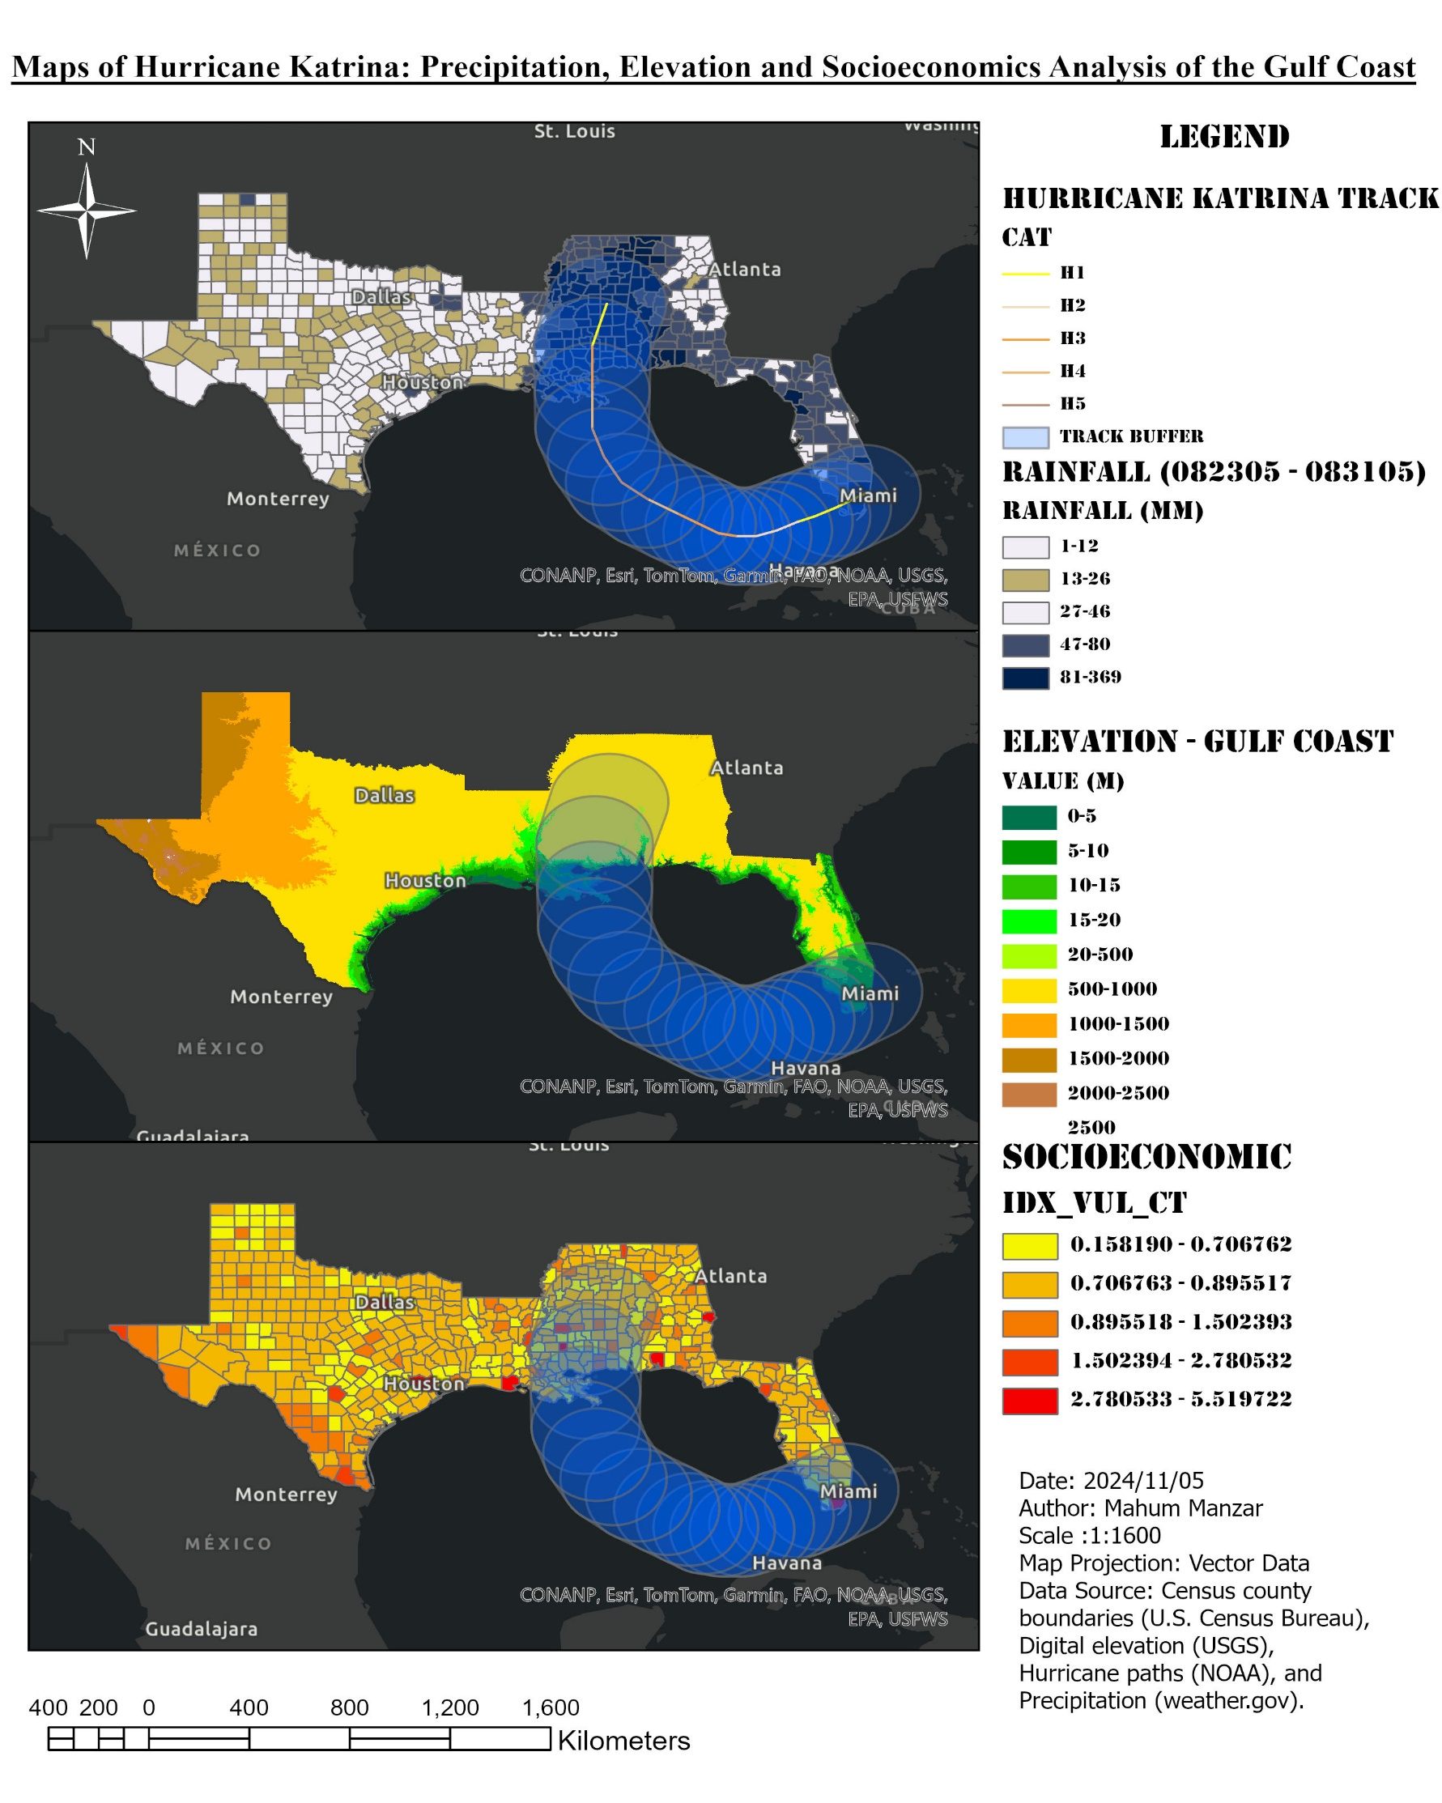

* Around 123 hurricanes of category H5 have hit the Gulf Coast since 1851.
* August 28th, 2005 was the day Hurricane Katrina became a Category 4 Hurricane for the first time.
* Orleans, Jefferson, Pearl River, St. Bernard, Hancock had an average of more than 10 inches of rainfall over the nine-day period associated with Hurricane Katrina in 2005.
* This kind of join is one-to-many. Since, one table was linked to many tables in the second data.
* The top 5 most vulnerable counties based on the socioeconomic analysis are Harris (Texas), Miami-Dade (Florida), Dallas (Texas), Bexar (Texas), and Tarrant (Texas).

BONUS QUESTION:

* The difference between using join and relate is that. When you use the join function you direction combine tables from the data using common field. Whereas, related function you combine tables from common field but they are kept separate.
* Spatial join uses spatial relations to combine tables.